Report for Assignment 4

Question 1

1. This code is saved in q1.py
   1. The program is two classes containing a method named recursive_count which recursively counts the number of nodes in a singly linked list.
   2. The input is a reference pointing to the first

node of the linked list.

* 1. The output is the number of nodes in the linkedlist.

1. Execute as followings:

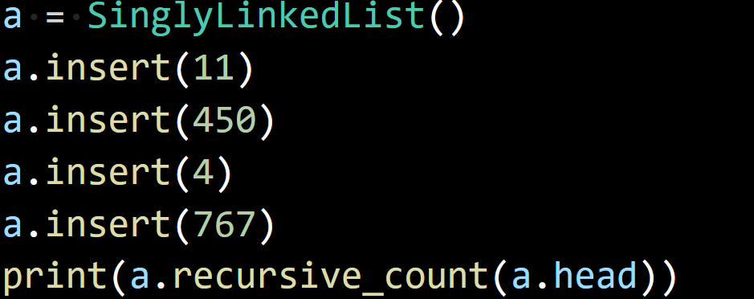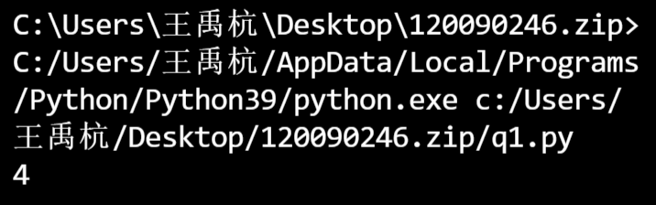

Question 2

1. This code is saved in q2.py
   1. The program can show the emirp (prime spelled backward) whose reversal is also a prime not including palindromic prime
   2. Input: A reference pointing to the first node of a linked list.
   3. Output: A reference to the first node of a linked list, in which the data have been sorted into the ascending order.
2. Execute as followings:

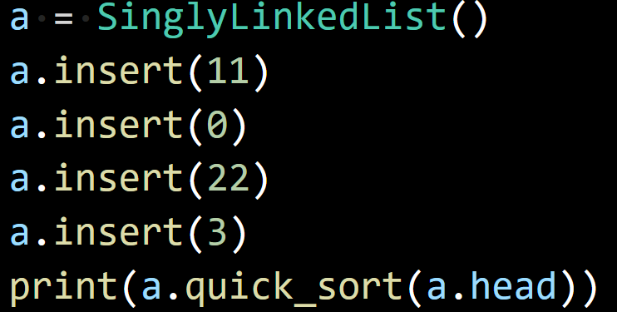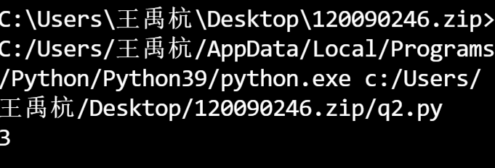

Question 3

1. This code is saved in q3.py
2. The program is to show the steps to move all the disks from rod A to rod C via rod B, following the rules:

(1). Only one disk can be moved at a time.

(2). Disk can only be moved if it is the uppermost disk on a stack.

(3). No disk may be placed on top of a smaller disk.

Users can input the value: the number of disks wanted.

The output is the steps to move all the disks from rod A to rod C via rod B.

3.Execute as followings:

